**Task 12:**

**Deploying a Static Website on AWS EC2 Using Cloud Front for Content Delivery**

**Deployed EC2 instance**

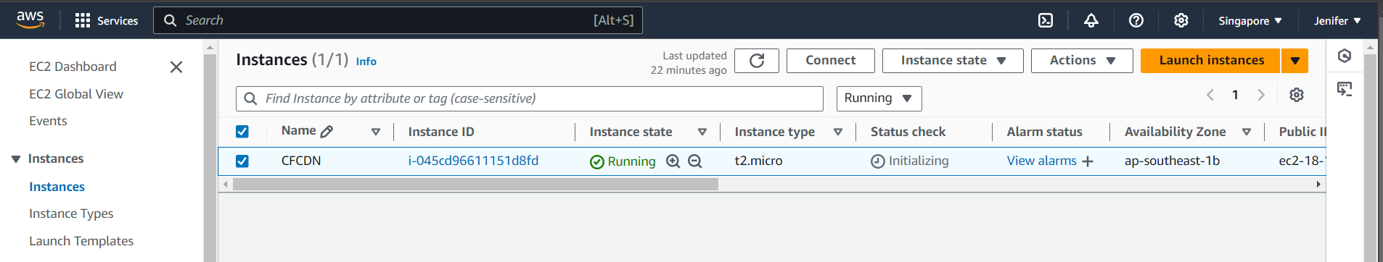

**I have created an Application Load Balancer**

**Created Cloud Front Distribution**

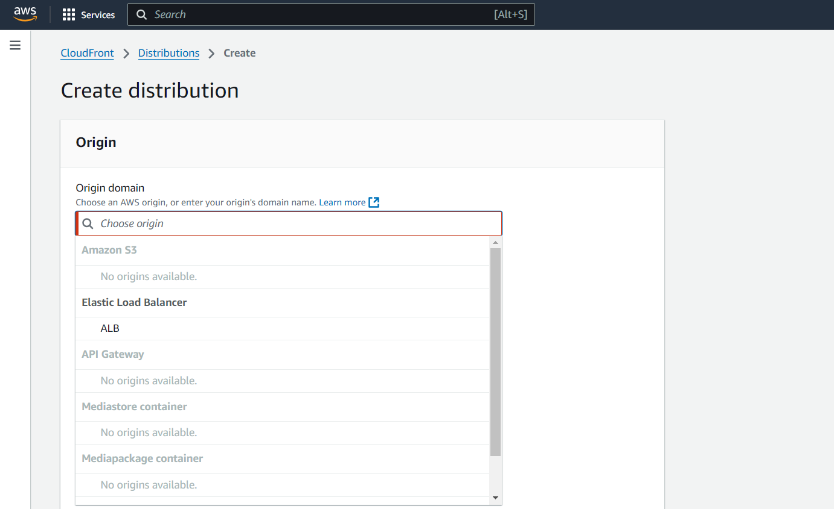

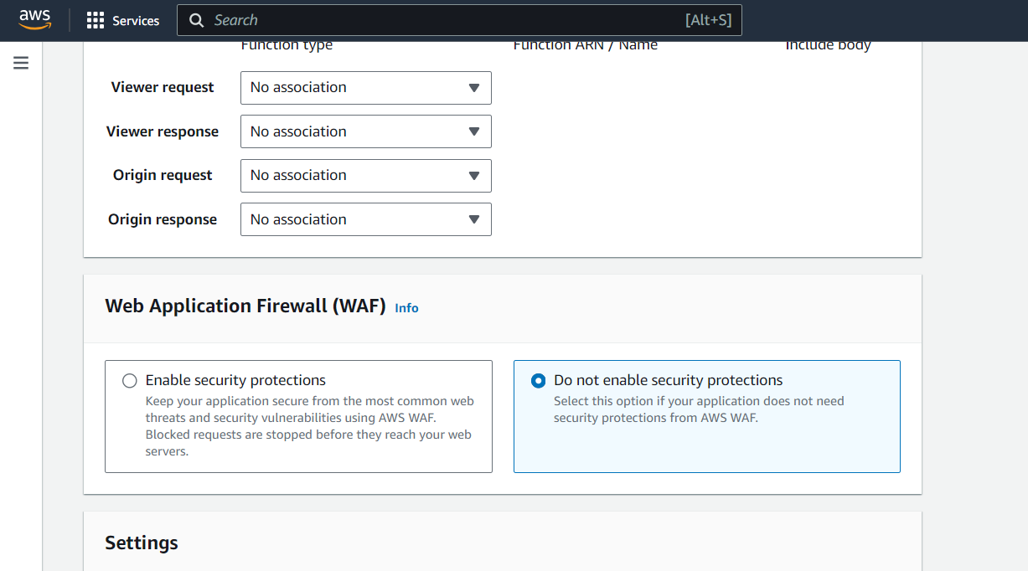

**Copied Distribution Domain Name**

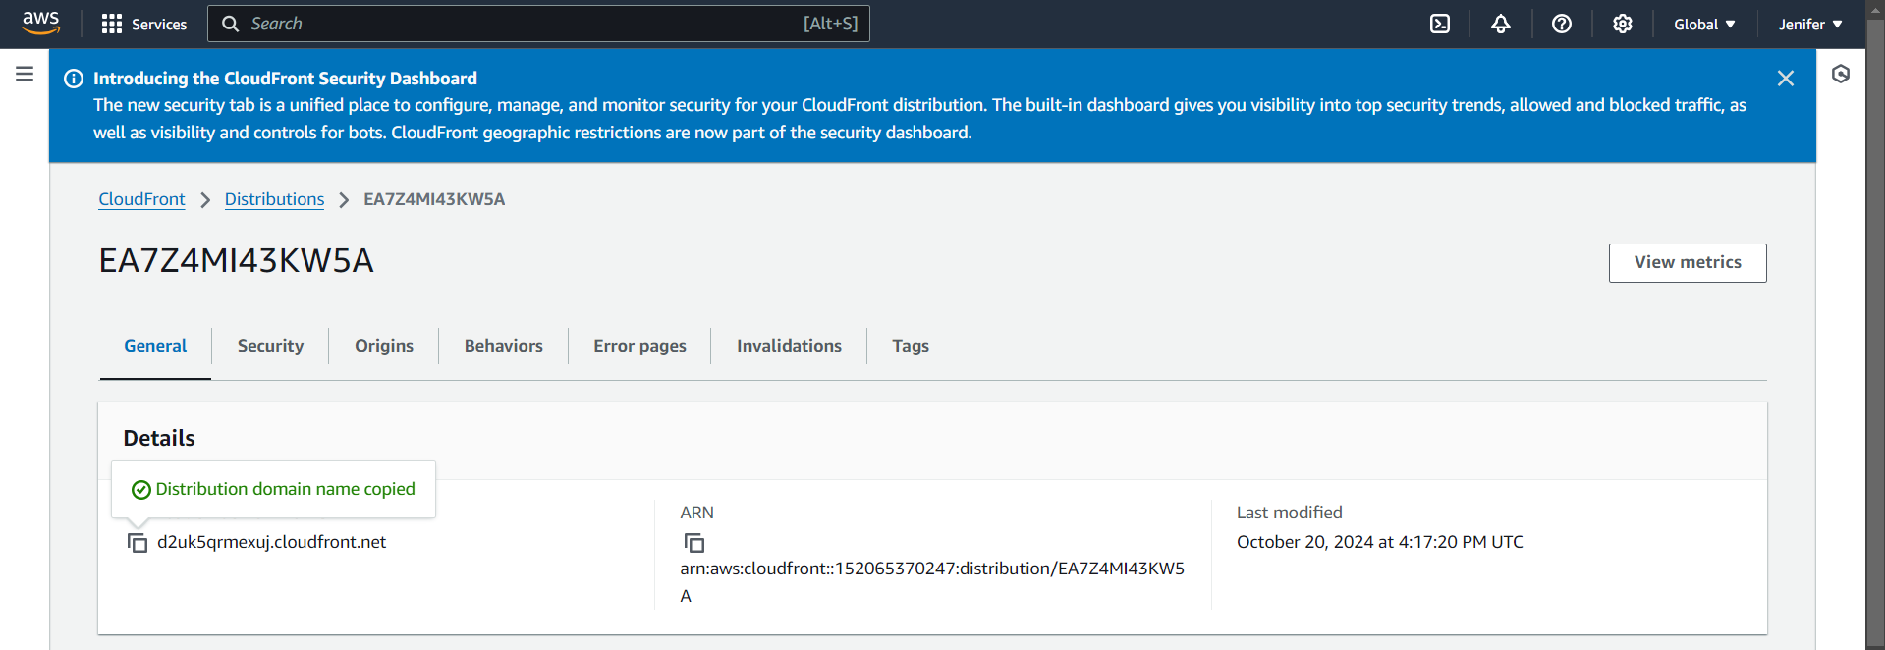

**Output**

